Git
Try to understand
(1) What is Version Control System?
(2) What is git?
(3) What is GitHub?
(4) ref video
https://git-scm.com/video/what-is-version-control
https://git-scm.com/video/what-is-git

Install git on your local machine (Laptop)
- Download https://git-scm.com/download
- Install using default option
- Git Install Tutorial https://youtu.be/tSpjw64A-kQ
- GitHub Account Create Tutorial https://youtu.be/-UWNSrpfavI

See the video
- https://youtu.be/FhbV6MSRrfs
- https://youtu.be/qZVY-XGG5Gg

Basic Git Operations
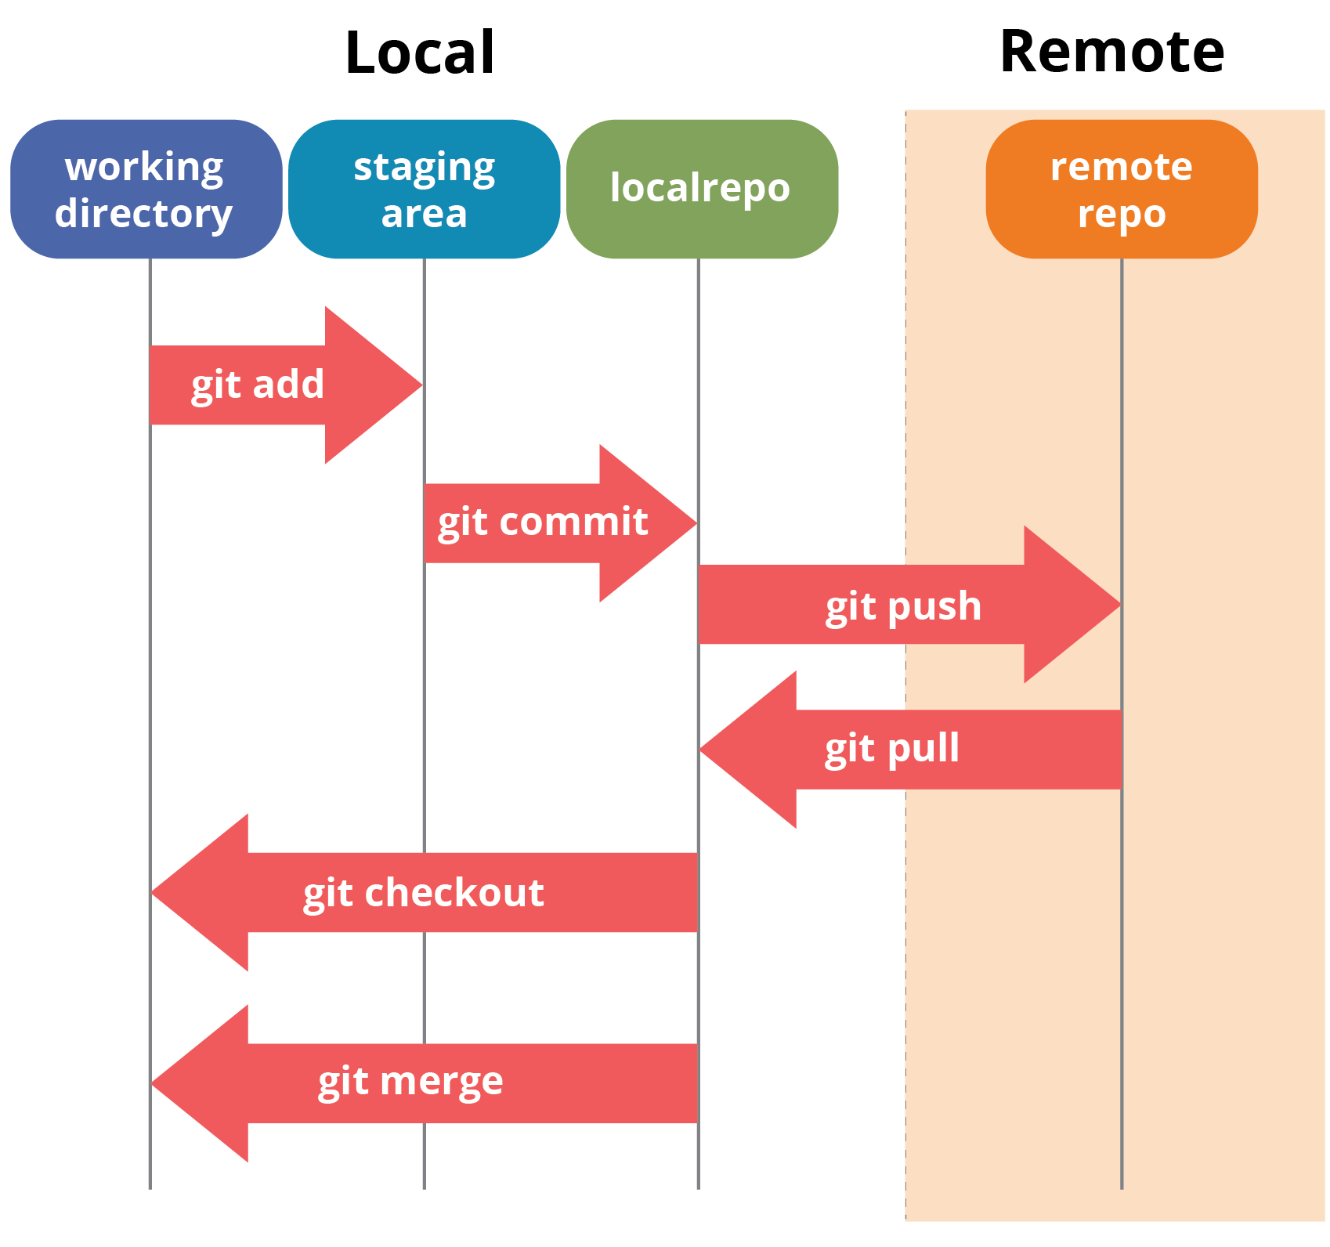
Image source - https://giorgi.pages.math.cnrs.fr/git_pres/#14

Git Commands
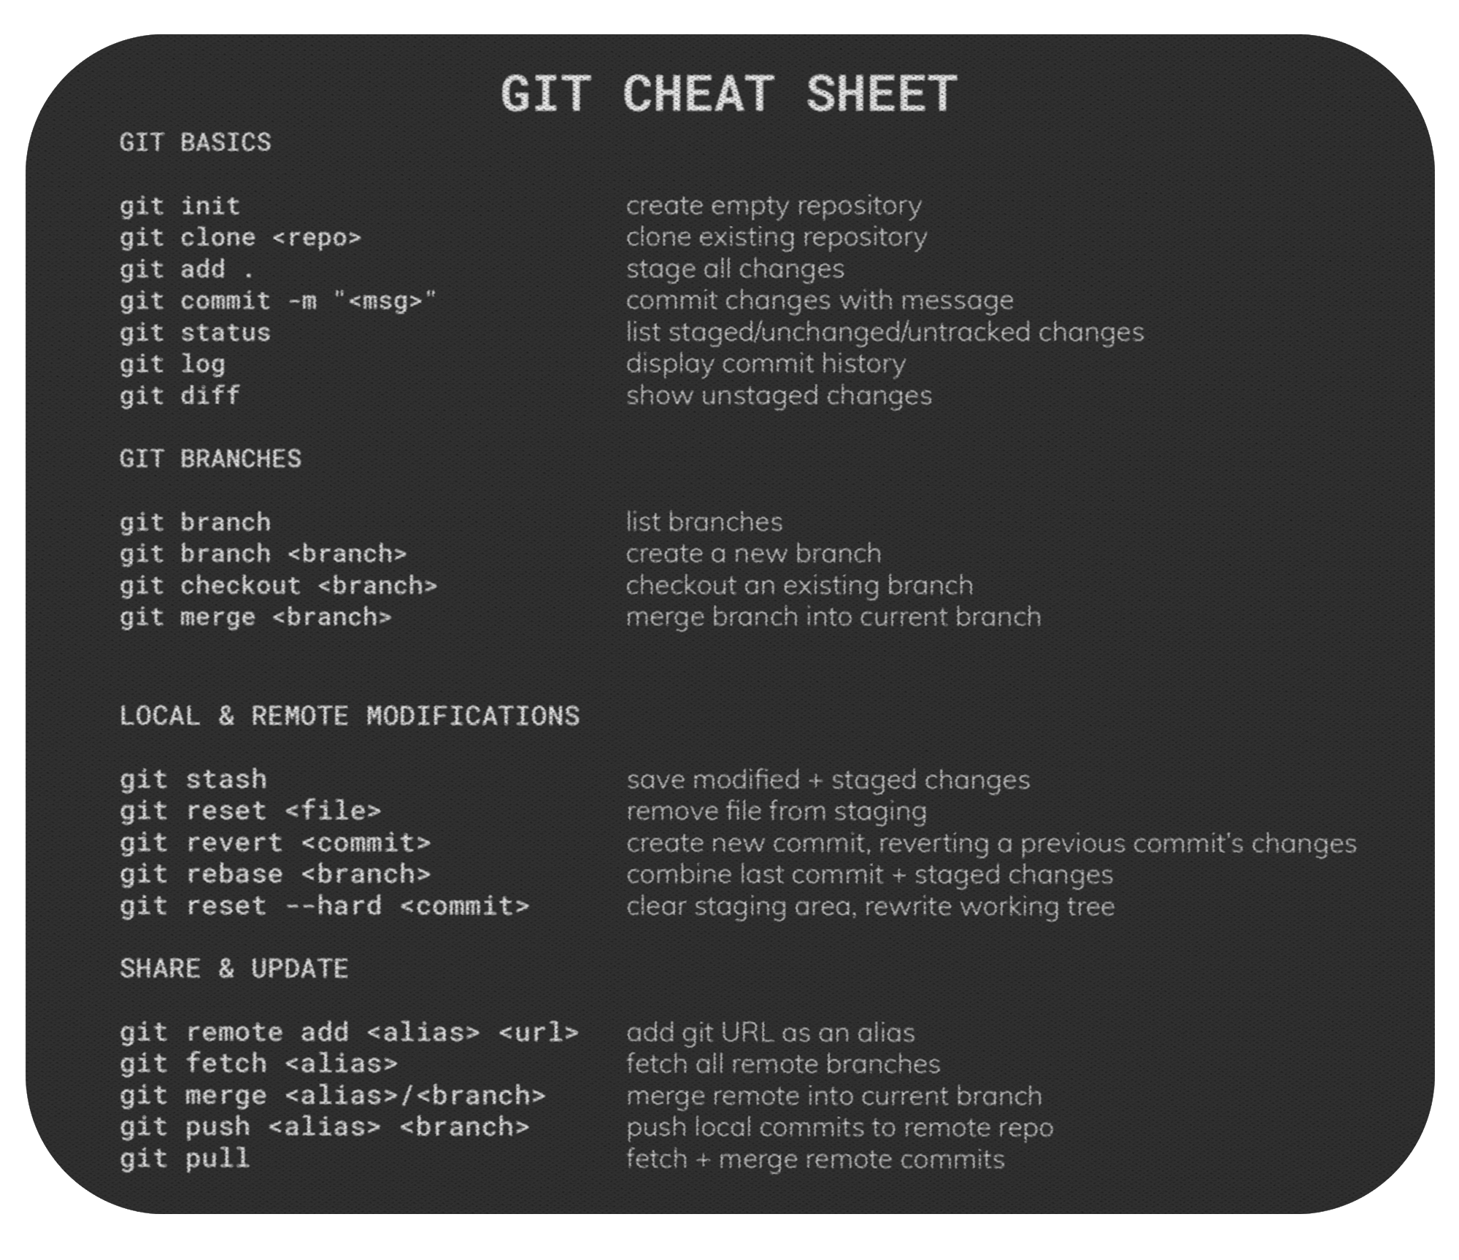
Image Source - https://shopkvlly.com/products/git-cheat-sheet-mousepad

Git Complete Tutorials Playlist
- https://www.youtube.com/playlist?list=PL6gx4Cwl9DGAKWClAD_iKpNC0bGHxGhcx
- https://www.youtube.com/playlist?list=PL4cUxeGkcC9goXbgTDQ0n_4TBzOO0ocPR

